# J.I.T Ordering System

Event table for the Customer

|  |  |  |  |  |  |
| --- | --- | --- | --- | --- | --- |
| Event | Trigger | Source | Use Case | Response | Destination |
| Customer creates an account | Creation of Account | Customer | Creation of Account | Account details | System |
| Customer inquiries about the item | Item Inquiry | Customer | Check item availability | Availability status | System |
| Customer order item | Order item | Customer | Order of item | Order details | System, Supplier |
| Customer cancel order | Cancel Order | Customer | Cancel of order | Cancelation of order | System, Supplier |
| Customer pay the item ordered | Payment | Customer | Payment | Payment details | System, Supplier |
| Customer receives invoice | Invoice | System | Received invoice | Invoice | Customer |
| Customer receives the item | Received Item | Logistics | Received item | Item details | Customer |

Event table for the Logistic System

|  |  |  |  |  |  |
| --- | --- | --- | --- | --- | --- |
| Event | Trigger | Source | Use Case | Response | Destination |
| Logistics received the item from the supplier | Received Item | Supplier | Received item | Item details | Logistics |
| Logistic deliver item to Customer | Shipping | Logistic | Delivery of item | Shipping details | Customer |

USE CASE DIAGRAM

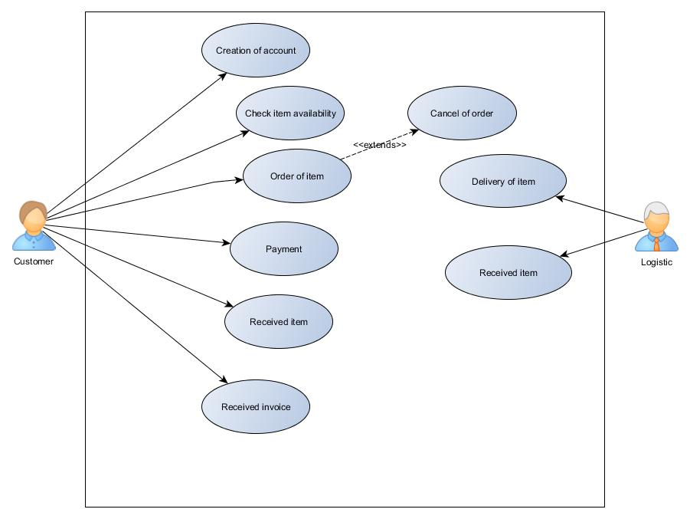

USE CASE FULL DESCRIPTION

|  |  |  |
| --- | --- | --- |
| Use case name: | Creation of account | |
| Scenario: | Customer creates her/his account | |
| Triggering Events: | Creation of account | |
| Brief Description: | The Create Account use case allows the User to create a login and become a Registered User. | |
| Actor/s: | Customer | |
| Related Use case: | Check item availability | |
| Stakeholders: | Owner, Customer | |
| Pre-conditions: | Customer must exist | |
| Post-conditions: | Account details and the customer is a registered user. | |
| Flow of Events: | Actor  1.) Customer will create an account | System   * 1. System will store the entered data in the user account. |
| Exception Conditions: | No customer  The customer have already an account | |

|  |  |  |
| --- | --- | --- |
| Use case name: | Check item availability | |
| Scenario: | Check the item availability and price | |
| Triggering Events: | To check if the item is available and how much the product is. | |
| Brief Description: | Checks the product availability and the price | |
| Actor/s: | Customer | |
| Related Use case: | Creation of account | |
| Stakeholders: | Owner, Customer | |
| Pre-conditions: | Customer must create an account | |
| Post-conditions: | Availability and the price of the product | |
| Flow of Events: | Actor  1.) Customer log in to the system  2.) Customer view item catalog | System  1.1)System sends the item info |
| Exception Conditions: | If there’s a customer but doesn’t have an account  If the product is not available | |

|  |  |  |
| --- | --- | --- |
| Use case name: | Order of item | |
| Scenario: | Customer orders the item in the system | |
| Triggering Events: | Order item | |
| Brief Description: | Customer order an item | |
| Actor/s: | Customer | |
| Related Use case: | Creation of account, Check item availability | |
| Stakeholders: | Owner, Customer | |
| Pre-conditions: | Customer must inquire an item | |
| Post-conditions: | Order details | |
| Flow of Events: | Actor  1.) Customer orders the item from the system. | System   * 1. System will process the order to the supplier   2. System will display the order details |
| Exception Conditions: | If the product is not available | |

|  |  |  |
| --- | --- | --- |
| Use case name: | Cancel of order | |
| Scenario: | Customer cancel an order | |
| Triggering Events: | Cancel order | |
| Brief Description: | Customer can cancel his/her order | |
| Actor/s: | Customer | |
| Related Use case: | Creation of account, Check item availability, Order item | |
| Stakeholders: | Owner, Customer | |
| Pre-conditions: | Customer must have an order | |
| Post-conditions: | The order is cancelled | |
| Flow of Events: | Actor  1.) Customer will cancel his/her order. | System   * 1. System will cancel the order of the customer. |
| Exception Conditions: | If the order is already delivered | |

|  |  |  |
| --- | --- | --- |
| Use case name: | Payment | |
| Scenario: | Customer pays the product | |
| Triggering Events: | Payment | |
| Brief Description: | Customer pays the product | |
| Actor/s: | Customer | |
| Related Use case: | Creation of account, Check item availability, Order item, Cancel ordere | |
| Stakeholders: | Customer, Owner | |
| Pre-conditions: | Customer must have an order | |
| Post-conditions: | Payment details | |
| Flow of Events: | Actor  1.) Customer pays the product.  2.) Customer received the payment details. | System   * 1. Create invoice |
| Exception Conditions: | If the customer has already pay the item | |

|  |  |  |
| --- | --- | --- |
| Use case name: | Received invoice | |
| Scenario: | The customer received the invoice | |
| Triggering Events: | Invoice | |
| Brief Description: | Receiving invoice | |
| Actor/s: | Customer | |
| Related Use case: | Creation of account, Check item availability, Order item, Cancel order, Payment | |
| Stakeholders: | Customer, Owner | |
| Pre-conditions: | Customer pays the product | |
| Post-conditions: | Invoice bill | |
| Flow of Events: | Actors  1.) After the customer pay the item he/she will receive invoice | System   * 1. The system will store the invoice bill. |
| Exception Conditions: | If the customer isn’t fully paid yet for the item the customer will not receive an invoice | |

|  |  |  |
| --- | --- | --- |
| Use case name: | Received item | |
| Scenario: | The logistic will deliver the item then customer will received the delivery | |
| Triggering Events: | Received item | |
| Brief Description: | The customer will receive the item delivered | |
| Actor/s: | Customer, Logistic | |
| Related Use case: | Creation of account, Check item availability, Order item, Cancel order, Payment, Received Invoice | |
| Stakeholders: | Customer, Owner | |
| Pre-conditions: | Customer pays the product and received the invoice | |
| Post-conditions: | Notification that the item is delivered | |
| Flow of Events: | Actors  1.) Customer received the ordered item | System   * 1. The system will notify the logistic. |
| Exception Conditions: | If there is a calamity the item will not be delivered. | |

|  |  |  |
| --- | --- | --- |
| Use case name: | Received item | |
| Scenario: | The logistics will receive the item delivered by the supplier | |
| Triggering Events: | Received item | |
| Brief Description: | The logistics will receive the item delivered | |
| Actor/s: | Logistic | |
| Related Use case: | Creation of account, Check item availability, Order item, Cancel order, Payment, Received Invoice, Received item | |
| Stakeholders: | Logistics, Owner, Supplier | |
| Pre-conditions: | The logistic pays his order | |
| Post-conditions: | The logistic will deliver right away to the customer after he received the item | |
| Flow of Events: | Actors   1. Logistics received the item 2. Logistics can now deliver the item | System   * 1. The system will notify that item is ready to deliver. |
| Exception Conditions: | If there is a calamity the item will not be delivered. | |

|  |  |  |
| --- | --- | --- |
| Use case name: | Delivery of item | |
| Scenario: | The item will deliver to the customer | |
| Triggering Events: | Shipping item | |
| Brief Description: | The logistics will receive the item delivered | |
| Actor/s: | Logistic | |
| Related Use case: | Creation of account, Check item availability, Order item, Cancel order, Payment, Received Invoice, Received item | |
| Stakeholders: | Logistics, customer, supplier | |
| Pre-conditions: | The logistic received the delivery of the supplier | |
| Post-conditions: | The customer received the item | |
| Flow of Events: | Actors  1.) Logistics deliver the item to customer | System   * 1. The system will verify if the item is received |
| Exception Conditions: | If there is a calamity the item will not be delivered or the delivery will be delayed. | |